**IPSITA MOHANTY**

**PROJECT DESIGN DOCUMENT**

{ADVENTUREWORKS2019DATABASE}

Abstract

{Through this document, it will help you to get into this project easily can have a detailed description about all the visuals and process happened in Power BI}

**CONTENTS:**

* Data Flow ------------------------------------------------------------------------------------------------------ 1
* Tables Used -------------------------------------------------------------------------------------------------- 1
* Data Model --------------------------------------------------------------------------------------------------- 1
* Joins Used ----------------------------------------------------------------------------------------------------- 2
* Data Enhancement Done ------------------------------------------------------------------------------ 2

Tables created --------------------------------------------------------------------------------------------- 2

Measures created ----------------------------------------------------------------------------------------- 2

* Dashboard Page --------------------------------------------------------------------------------------------- 3

Page Navigation Used ------------------------------------------------------------------------------- 3

Filters Used ---------------------------------------------------------------------------------------------- 4

* Premium Page ------------------------------------------------------------------------------------------------ 5

Bookmarks ----------------------------------------------------------------------------------------------- 6

* Publish the report ------------------------------------------------------------------------------------------- 7
* Sharing the report with the Clients ------------------------------------------------------------------ 7

**HOW DATA FLOW?**

Data Source -

FactInternetSales

Power BI Desktop

Power BI Service

DimCustomer

Client

Report Development

DimSalesTerritory

DimProduct

**Table Used –**

* FactInternetSales
* DimProduct
* DimCustomer
* DimSalesTerritory

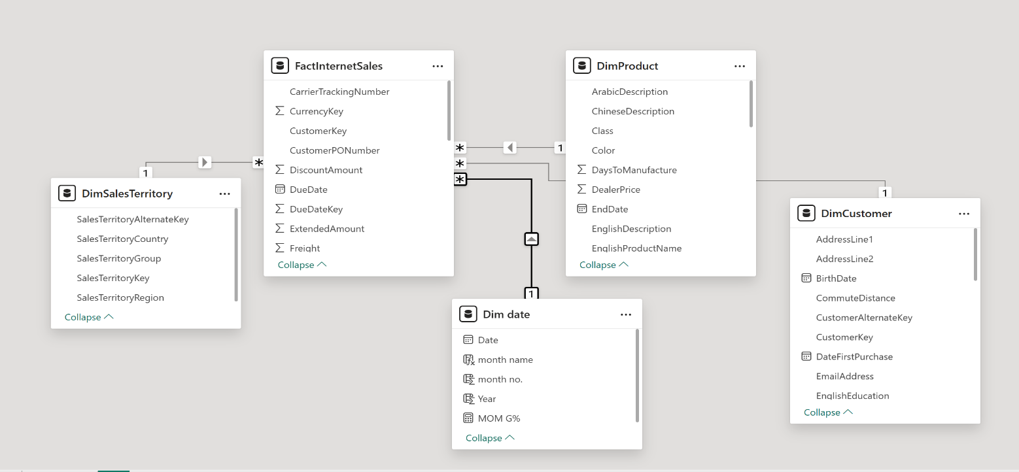 **Data Model –**

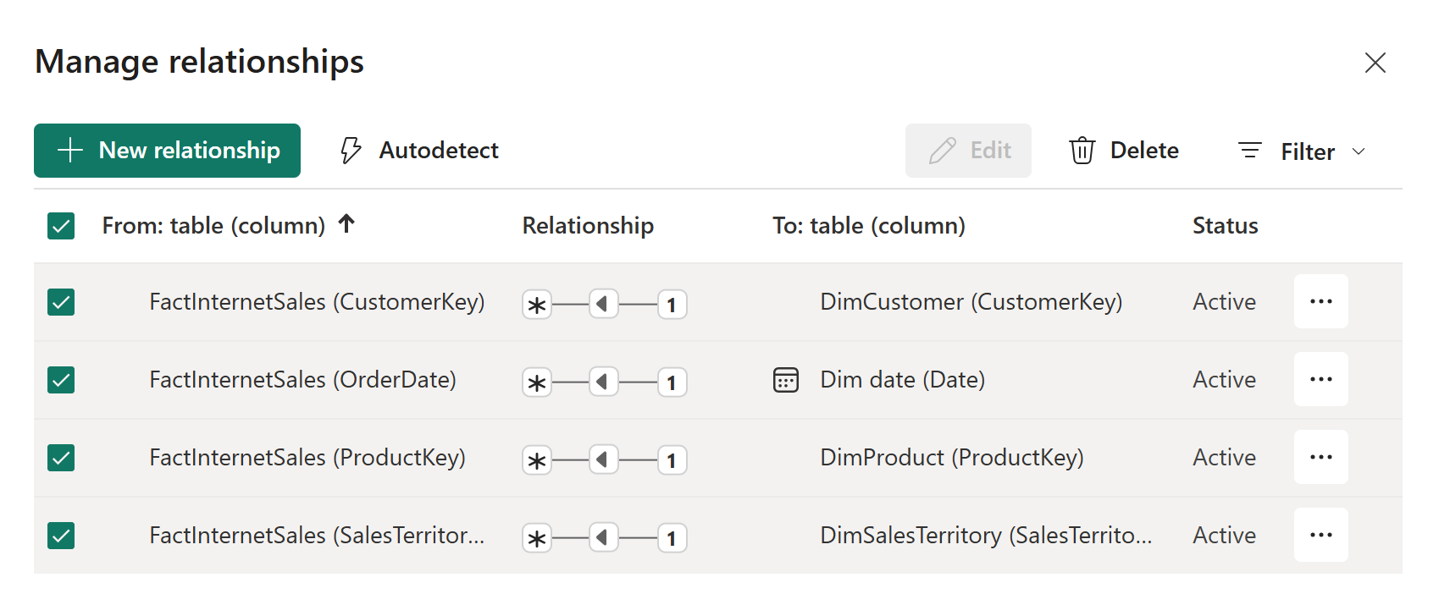**Joins Used –**

**Data Enhancement Done –**

**Tables created:**

Dim Date: - This is a date dimension tables which is required to use Time Intelligence

functions like YOY, YTD etc.

* DimDate = CALENDER(MIN(DimProduct[StartDate], MAX(DimPrdoct[EndDate]))
* Year = YEAR(DimDate[Date])
* Month = Month (DimDate[Date])
* MonthName = Format (DimDate[Date],” MMMM”)

**Measures Used:**

YOY G% =

var cys = SUM(FactInternetSales[SalesAmount])

var pys = CALCULATE(SUM(FactInternetSales[SalesAmount]), PREVIOUSYEAR ('Dim date'[Date]))

var result = DIVIDE (cys-pys,pys,BLANK())

RETURN

result

MOM G % =

var cms= SUM(FactInternetSales[SalesAmount])

var pms= CALCULATE(SUM(FactInternetSales[SalesAmount]), PREVIOUSMONTH ('Dim date'[Date]))

var result = DIVIDE (cms-pms,pms,BLANK())

RETURN

result

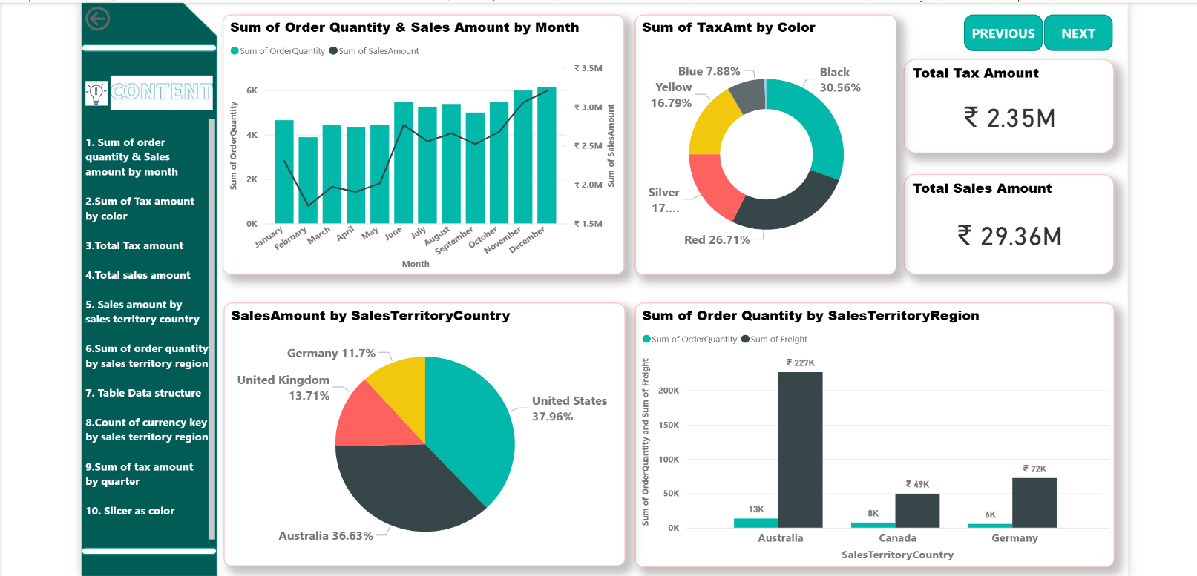**Dashboard Page –**

**Page Navigation Used –**

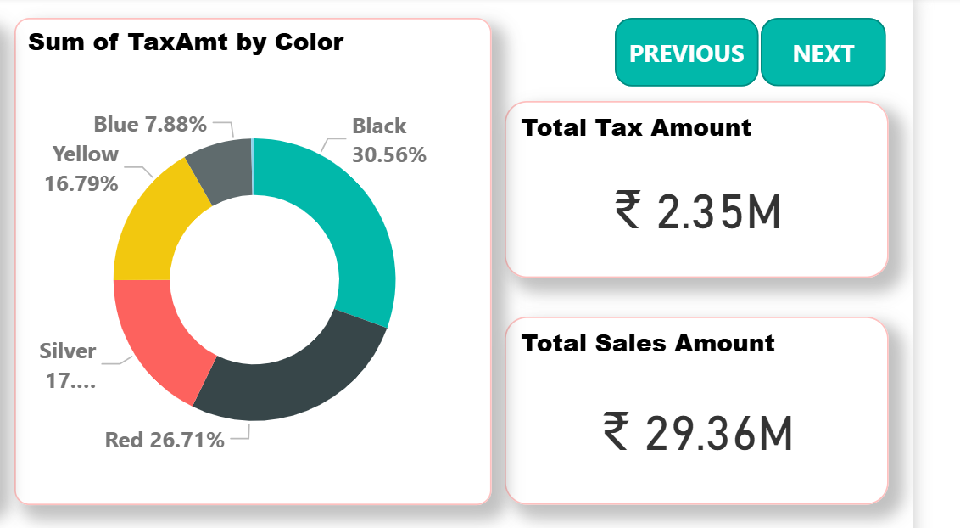When we click on next it will take us to Premium Page, and when we click on Previous it will take us to Dashboard Page & vice-versa.

**Filters Used –**

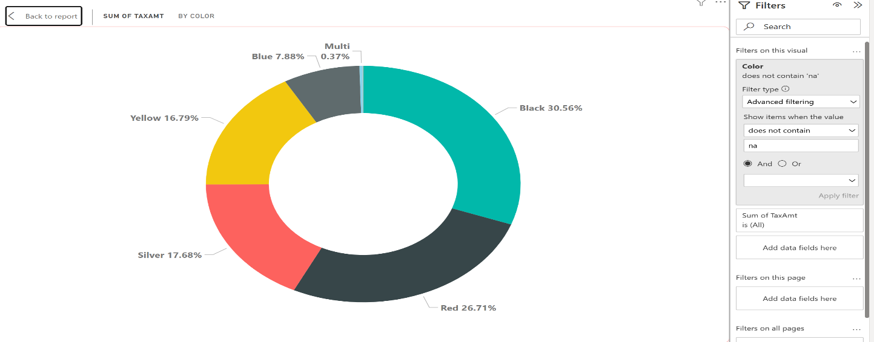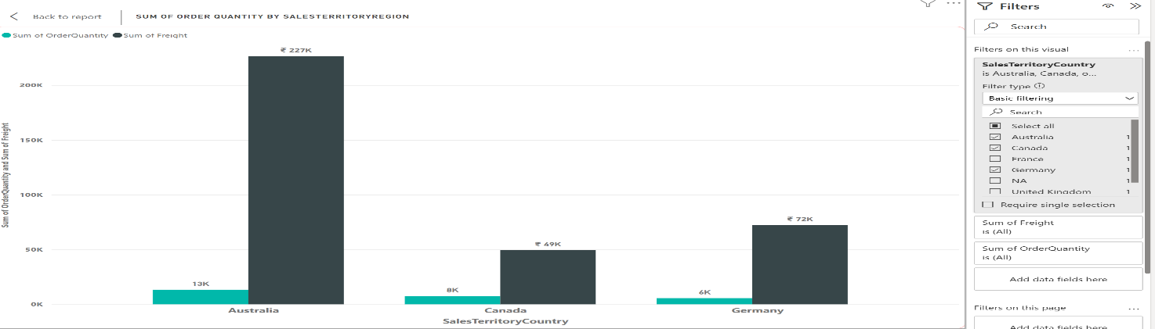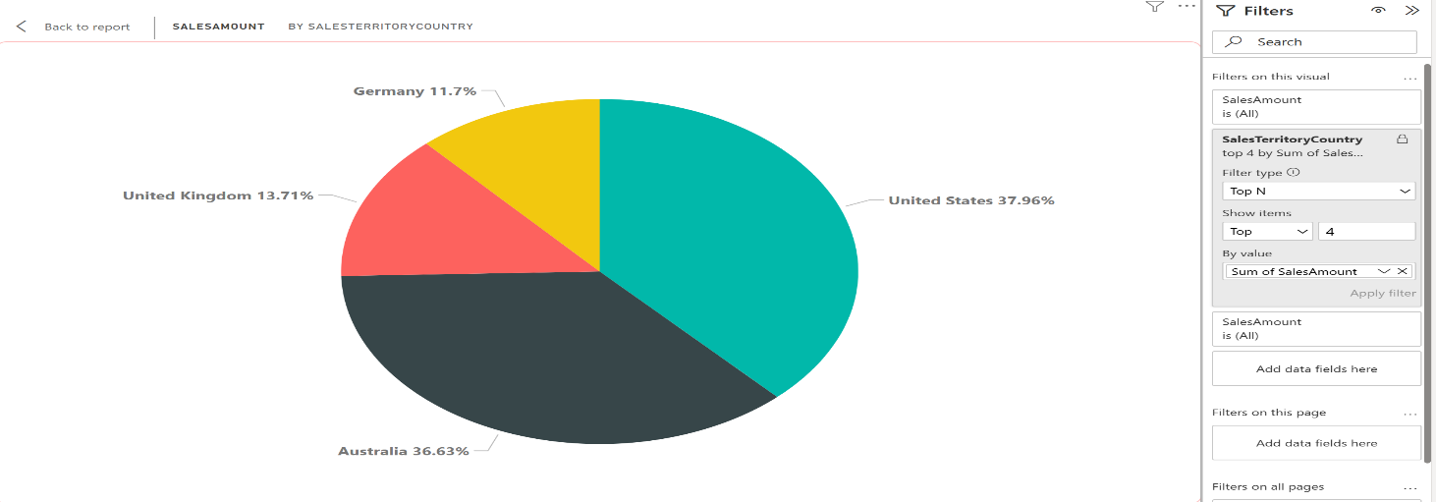 Here, in all this visualizations Filter on this visual is used.

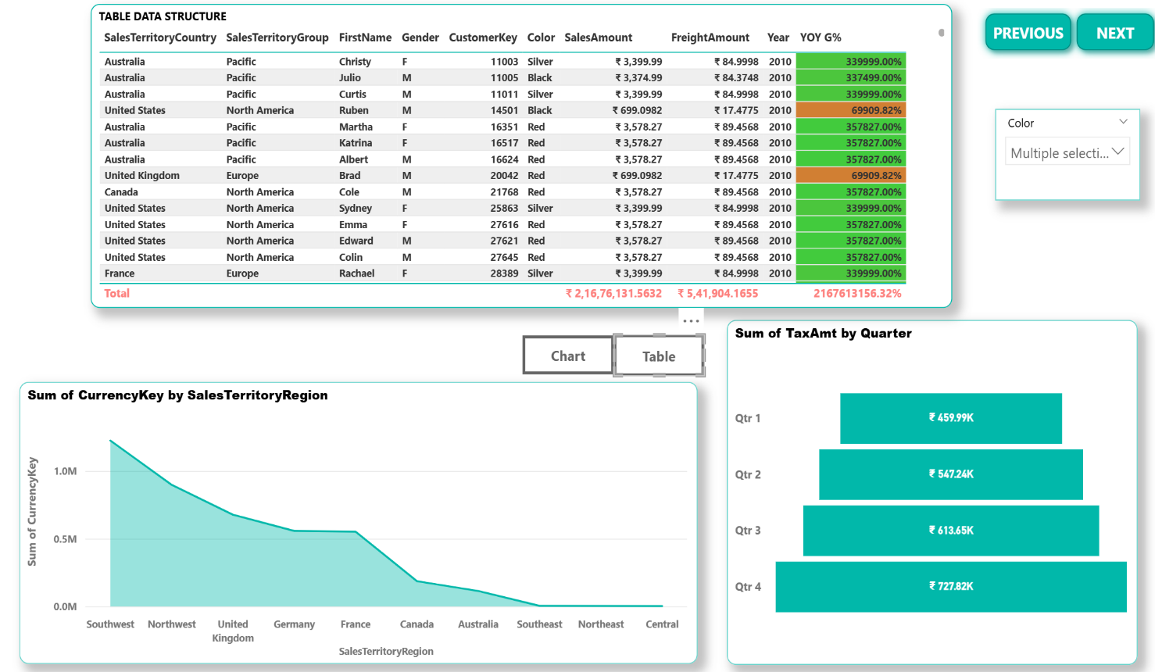**Premium Page -**

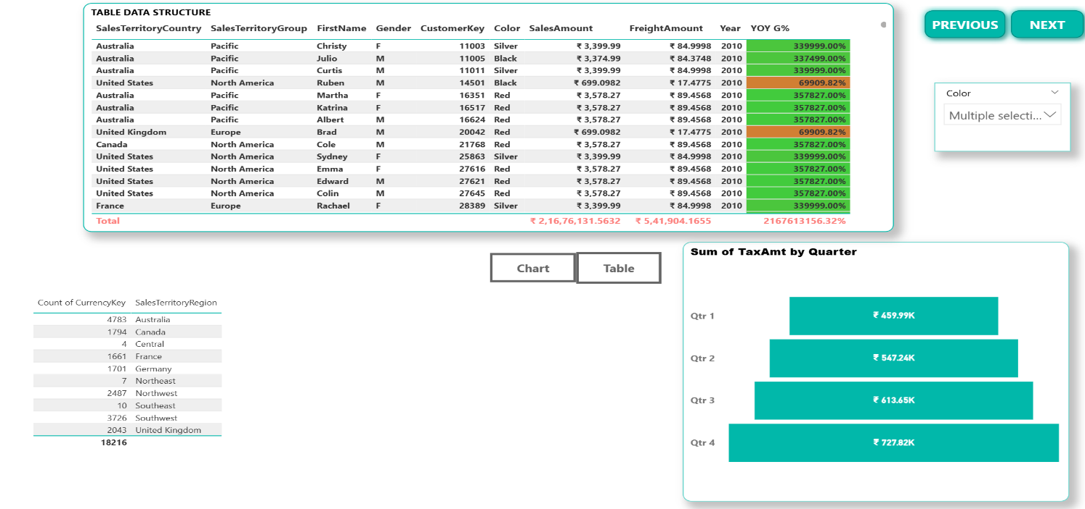

**Conditional Formatting** done in YOY G% as per the sales amount.

When the sales amount is less it will be on “RED” color and when it’s high it will be on “GREEN” color.

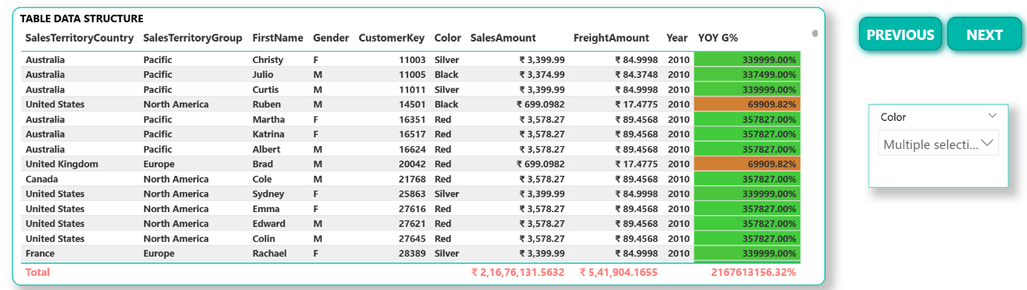Based on this slicer, i.e.; selected color we can see the Table Data Structure.

**Bookmarks –**

Created bookmarks one for Table visual and the other for Area Chart visual.

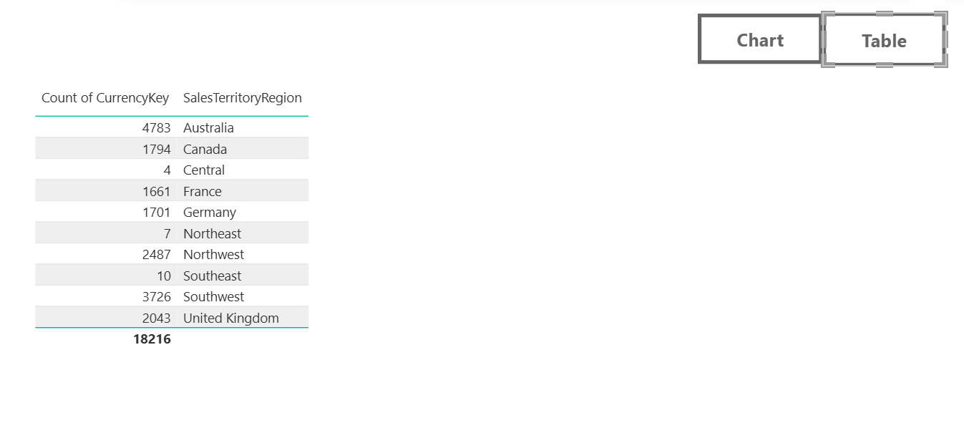 When we click on Table it shows this visual,

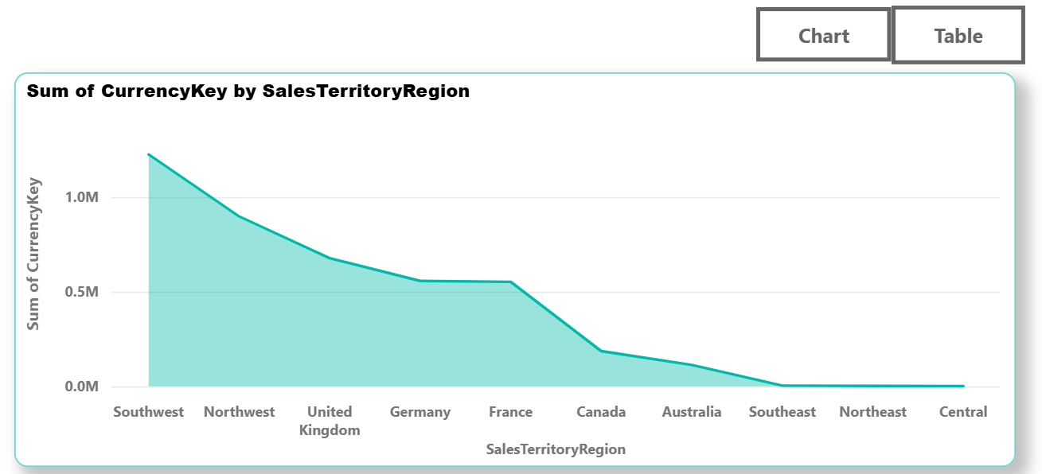and when we click on chart it shows this visual.

**Pub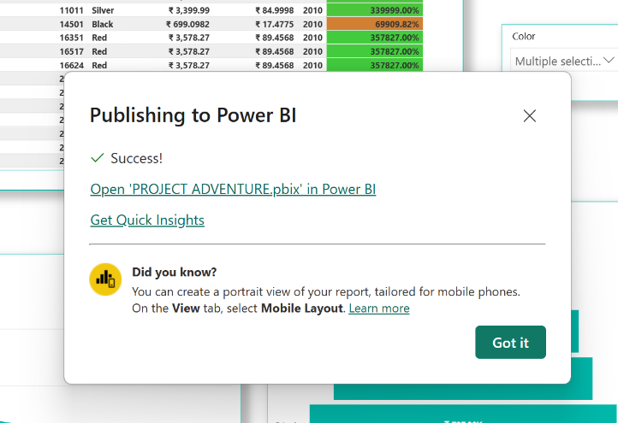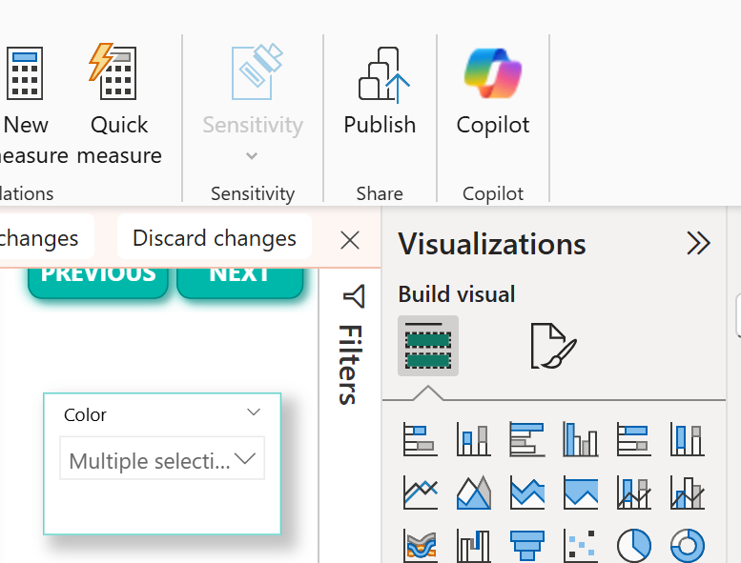lish the report –**

Successfully Published on Power BI Service.

**Sharing of report with the End users (Clients) -**

* We can click on the below link to get the report.

[**https://app.powerbi.com/reportEmbed?reportId=88e27b1e-567c-4cba-87df-2e75bf51f6a2&autoAuth=true&ctid=af40f3ff-d398-4878-8d60-9f6e29491574**](https://app.powerbi.com/reportEmbed?reportId=88e27b1e-567c-4cba-87df-2e75bf51f6a2&autoAuth=true&ctid=af40f3ff-d398-4878-8d60-9f6e29491574%20%20)

* We can check through this app to get the report.

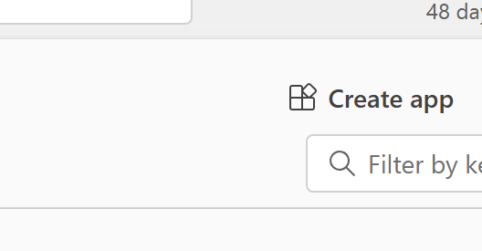

Through this app it got published.

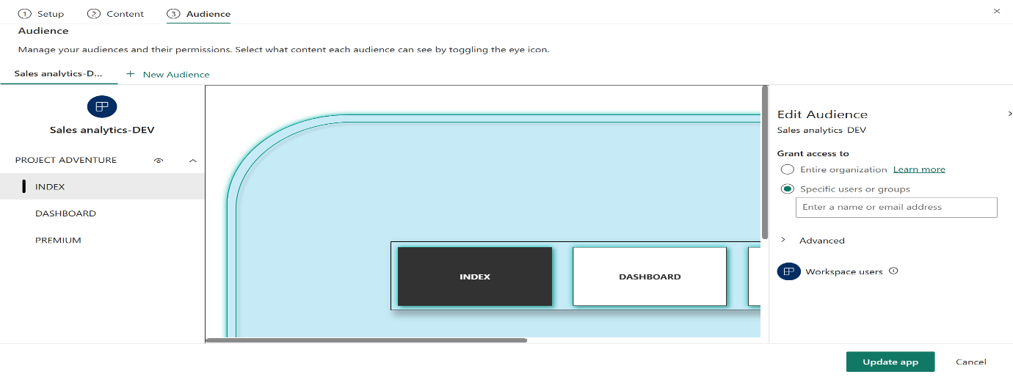

[**https://app.powerbi.com/Redirect?action=OpenApp&appId=69643ef4-e52d-4f49-a821-1279a1c524e6&ctid=af40f3ff-d398-4878-8d60-9f6e29491574&experience=power-bi**](https://app.powerbi.com/Redirect?action=OpenApp&appId=69643ef4-e52d-4f49-a821-1279a1c524e6&ctid=af40f3ff-d398-4878-8d60-9f6e29491574&experience=power-bi)

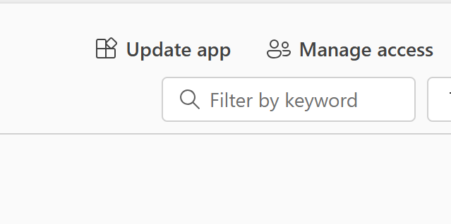 Now we only required to update app if any further changes happen.

**Thank You.**